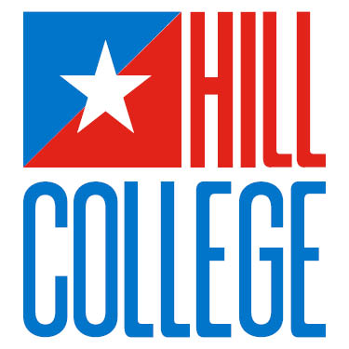

PHOTO RELEASE FORM

I hereby grant Hill College permission to use my likeness in a photograph or a video in any and all of its publications, including outside billboards and websites, without payment or any other consideration.
I understand and agree that these materials and photographs are the property of Hill College.
I hereby irrevocably authorize Hill College to edit, alter, copy, exhibit, publish or distribute these photographs for purposes of advertising, marketing, and publicizing Hill College’s programs or for any other lawful purpose. In addition, I waive the right to inspect or approve the finished product, including written/physical or electronic copy, wherein my likeness appears. I also waive any right to royalties or other compensation or considerations arising or related to the use of these photographic materials.
I hereby hold harmless and release and forever discharge Hill College from all claims, demands, and causes of action which I, my heirs, representatives, executors, administrators, or any other person acting on my behalf of my estate have or may have in the future by reason of this authorization and release.
_______I am at least 18 years of age and am competent to contract in my own name and represent myself. I have read this document before signing and I fully understand the contents, meaning, and impact of this agreement.
_____________________________________________________ ________________________
Signature Date
_____________________________________________________
Printed Name
______ I am NOT 18 years of age. I have read this document before signing and I fully understand the contents, meaning, and impact of this agreement and my signature must be accompanied by that of a consenting parent or guardian, as follows:
_____________________________________________________ ________________________
Signature Date
_____________________________________________________
Printed Name
I hereby certify that I am the parent or legal guardian of_________________________________, named
above, and I do hereby give my consent without reservation or further consideration to the foregoing on behalf of this minor child.
____________________________________________________ _________________________
Signature of Parent/Legal Guardian Date
_____________________________________________________
Printed Name of Parent/Legal Guardian Updated 10.2.19

